**ABSTRACT**— The SwiftCart project aims to change the shopping experience by offering a new RFID payment method. The main goal is to eliminate[[1]](https://paperpile.com/c/3hCTSL/fxD0) inefficiencies associated with traditional control systems, especially long queues and billing errors. Our solution combines RFID technology with user-friendly features to enable efficient scanning. During scanning, product information, including quantity, is automatically displayed on the LCD screen. Moreover, users have the option to change their choices using the special cancel button to ensure their satisfaction. The system promotes transparency and convenience by providing users with a complete summary of their purchases through real-time information on the LCD screen. SwiftCart aims to improve sales processes, improve customer experience and set new standards for e-commerce efficiency by leveraging the latest technology.

1. **INTRODUCTION**

In the fast-paced world, traditional checkout systems often lead to long queues and manual errors, negatively impacting customer experience and efficiency. Considered a game changer, SwiftCart offers an RFID payment system that aims to reduce these problems. SwiftCart seamlessly combines RFID technology with a deep user experience, enabling fast product scanning, efficient receipt updates, and easy checkout. SwiftCart aims to redefine the shopping experience and set new standards for efficiency, convenience and customer satisfaction with its new functionality, which includes reporting all purchasing information on the LCD screen. In addition to improving the payment process, SwiftCart is also changing the business landscape by leveraging the power of data analytics. Through analysis of purchasing patterns and product combinations, retailers gain valuable information about customer behavior and preferences, enabling targeted marketing campaigns and the development of specific activities. Additionally, SwiftCart integrates with mobile payment systems and loyalty programs that increase customer engagement and encourage loyalty. SwiftCart represents a dynamic shift in sales with its ability to adapt to consumer needs and offers ways to increase efficiency, profitability and customer satisfaction in today's market.

**II. MATERIALS AND METHODS**

The equipment required to develop an RFID-compatible control system includes an Arduino UNO microcontroller, a prototype board, a feedback buzzer, an RFID reader module for scanning RFID tags, and the RFID itself for product identification. Additionally, an LCD display is used to provide real-time charging information, while jumpers establish the connection between components. As indicators, red and green LEDs show the status of thescan. The project[[2]](https://paperpile.com/c/3hCTSL/ZuCs) begins with a comprehensive requirements analysis to define the system's goals and user needs. After this, appropriate materials are selected, taking into account compatibility and functionality. A detailed circuit diagram is then drawn, paying close attention to the metal and placing the parts on the table.Assembling the device involves connecting the RFID reader module to the Arduino UNO, connecting the LCD display, and setting the buzzer and LED. At the same time, Arduino code was developed to manage the RFID reader, process signal data, update the LCD display, and control the buzzer and LED. The software ensures accurate scanning, update time and user experience. Following hardware and software installation, extensive testing is performed to ensure the system is functional, efficient and reliable. User interface design is designed to improve user experience by focusing on the presentation and feedback process. Performance evaluations include evaluating the operating system's speed, accuracy, and user satisfaction. Complete documentation is maintained throughout the project, including circuit diagrams, code details, test methods and test results. The final application of the simulation product enables the collection of feedback; This allows for further improvements and ensures that the system achieves its goals of simplifying the audit process, reducing errors, and improving the customer experience.

**Hardware Requirements :**

* Arduino UNO
* Bread Board
* Buzzer
* RFID reader module
* RFID tags
* LCD Display
* Jumper wires
* Red and Green LEDs

**Software Requirements:**

* Arduino IDE
* Tinker

**III. EXISTING SYSTEM**

Today's retail system relies heavily on manual checkout processes, which often results in long queues and billing errors. Customers are forced to wait in line to have their items scanned and manually entered for payment, leading to delays and frustration. Moreover, data management in large enterprises creates problems due to the lack of appropriate storage and processing methods. This can lead to data loss, inconsistencies, and analytical problems. Additionally,traditional RFID systems focus primarily on one-to-one interactions or tracking of items in the supply chain.

**IV. PROPOSED SYSTEM**

With the introduction of RFID billing systems used in point-of-sale systems, our solution simplifies the audit process. [3] Customers use RFID cards to pay for items, with detailed information displayed on the LCD screen to provide transparency and allow them to make changes. The system provides rapid auditing, reducing queues and errors associated with manual operations. It increases efficiency and customer satisfaction in the environment with integration and real-time updates.The proposed system offers a number of advantages, including a simplified control system that reduces long queues and delays, providing better customer satisfaction and less customer churn. Additionally,[4] implementing an invoicing system reduces errors in cost and inventory management, allows for better verification and coordination, and ultimately results in increased revenue and efficiency.

**V. APPROACH**

The process of developing an RFID-enabled control system involves a structured approach divided into key areas. Initially, a comprehensive needs analysis is carried out to define the goals of the system, and then a circuit diagram is made using the Tinker platform. Hardware components including Arduino UNO, RFID reader, LCD screen, buzzer, LED and jumper cables are selected schematically and connected to the board.program development includes an Arduino program to manage RFID tag reading, display updates and control feedback using the Liquid Crystal Display I2C library. The hardware and software are then integrated and full testing is performed, including adding and removing parts from the bike, to ensure real-time accuracy. Finally, the system is sent to the retail market for evaluation and improvement to ensure it meets user expectations and operational requirements.

1. **Design and planning**

The first step involves defining the project requirements and creating a detailed plan for implementation. This begins with a thorough requirement analysis to identify the needs of the checkout system, including the necessary hardware components, software functionalities, and user interface requirements. Following this, a system architecture design is created, outlining the schematic layout of the system. This design details the connections between the Arduino UNO, RFID reader, [5] LCD display, buzzer, LEDs, and other components. The circuit diagram was built using the Tinker platform, providing a clear and detailed blueprint for the subsequent stages of the project. This comprehensive planning phase ensures that all project aspects are well-documented and understood before proceeding to implementation.

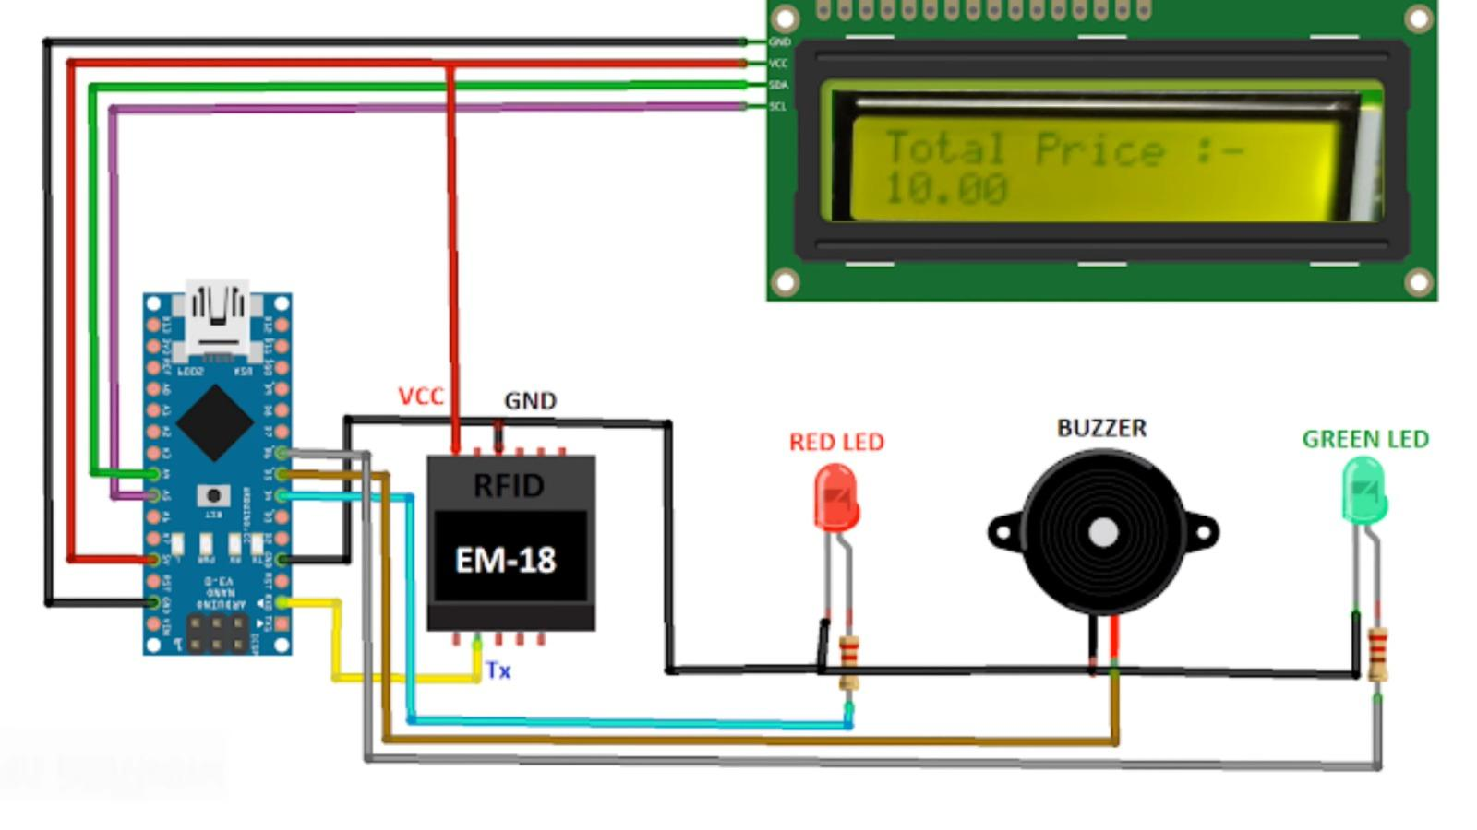 Fig.1. System Design

1. **Hardware Integration**

In this phase, all hardware is mounted and connected according to the system design. The process starts with selecting and purchasing the right components such as Arduino UNO, RFID reader module, LCD screen, buzzer, LED and connecting cables. After the components are found, the circuit design is carried out by connecting all [6] components to the breadboard according to the design created with Tinker. This ensures everything is properly wired and placed;

provides a reliable basis for the system. Initial tests are performed to determine the functionality and compatibility of all components so that the installed hardware is ready for software integration.

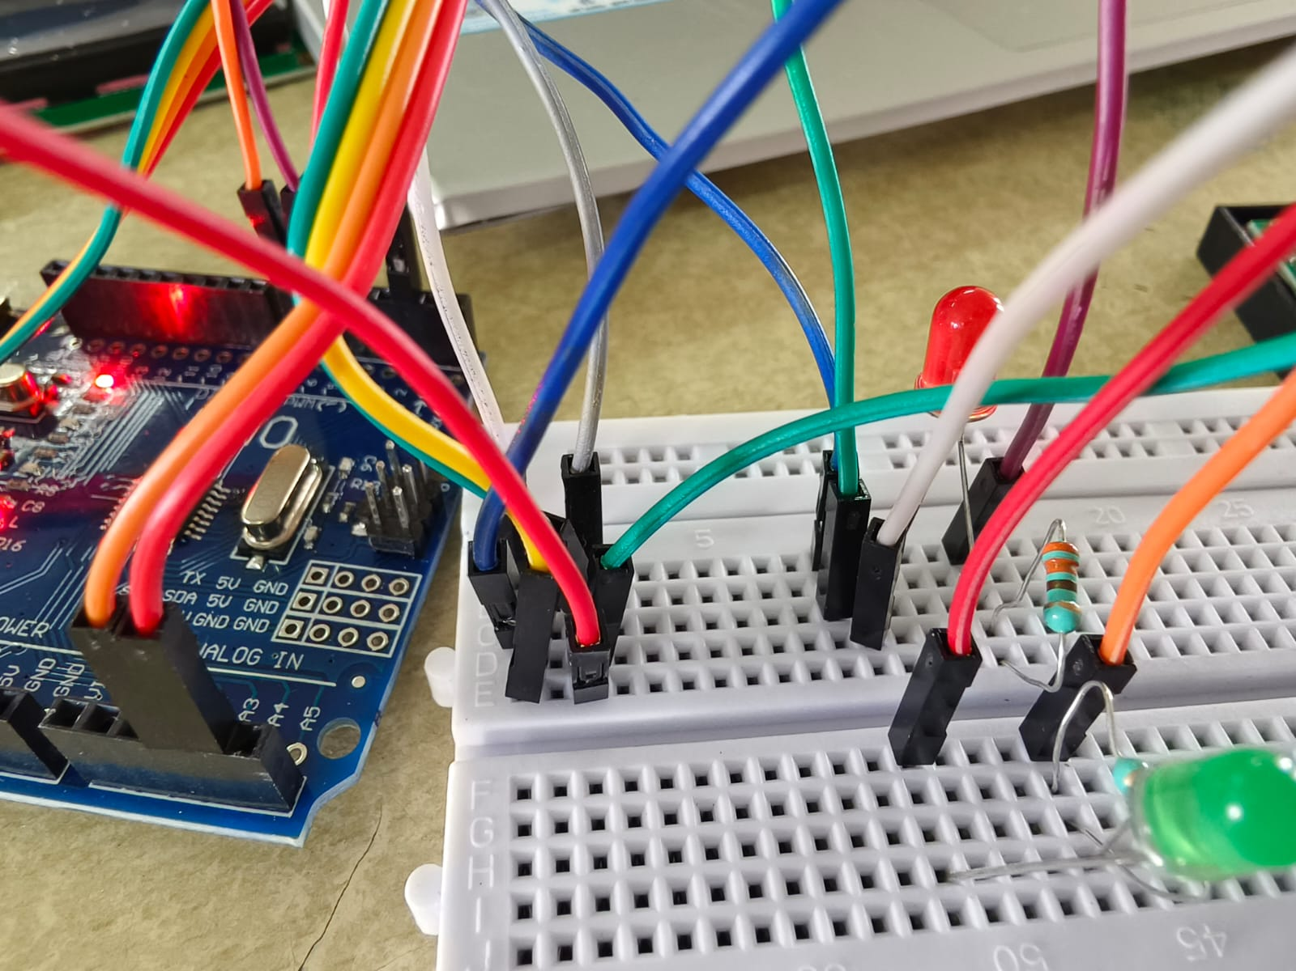

Fig.2. Hardware setup

1. **Software Development**

The software development phase focuses on writing the code necessary to control the hardware and manage the functionality of the system. This includes RFID tag reading, data processing, LCD display updates, buzzer activation, and Arduino programming for the LED display. The Liquid Crystal Display I2C library is included to facilitate the display of information on the LCD screen and improve the user experience. The code is well written so that everything in the works well and is compatible with others. Troubleshooting procedures are implemented to resolve any problems that may arise and appropriate troubleshooting is performed to ensure trouble-free operation of the system. This phase is necessary for the system to operate as intended, with reliable and responsive operation that meets the user's needs.

1. **System Integration and Testing**

Once the hardware and software components are developed, they are combined into an integrated system. This involves integrating integrated hardware with advanced software so that they can work together seamlessly. Extensive testing is performed to determine the functionality of the system, including accurate scanning, real-time billing updates, and user feedback. Testing includes practical aspects such as adding and removing items from the shopping cart so that the system can respond accurately and precisely. User acceptance tests are also conducted in a simulated environment, allowing potential users to interact with the system and provide feedback on its usability and performance. This concept is invaluable in adapting and improving as needed to ensure the system effectively achieves its goals.

1. **Refinement**

The final phase focuses on using the system in the real environment and improving the system based on user feedback and performance evaluation. The system was installed on a comparative product to demonstrate its capabilities and collect practical information. In this section, you will find detailed information such as system design, technical specifications, schematics, Arduino code, test methods and performance evaluation. This extensive documentation ensures that the project can replicate their improvement upon it in the future. The feedback collected during this phase is used to identify potential improvements and future developments, such as improving the user experience, optimizing response times, and coordinating additional activities. This process of continuous evaluation and improvement ensures that the system is constantly adjusted and evaluated to adapt to needs while maintaining the effectiveness and efficiency of the product.

**VI. RESULT**

Results obtained from RFID-enabled production control systems show significant improvements in product control performance and user satisfaction. Thanks to extensive testing, the system consistently performs well in terms of scanning, update time and user experience. Additionally, the combination of indicators such as LED and buzzer improves the user experience, providing clear and rapid feedback during inspections.Project discussions reveal the potential of RFID technology to be used in retail, providing opportunities to increase efficiency and customer engagement. Overall, RFID-enabled POS systems represent a fundamental advancement in point-of-sale technology and set new standards for efficiency, convenience and customer satisfaction.

**VII. OUTPUT**

The output of the RFID system used by the operating system greatly enhances the shopping experience. When customers scan RFID tagged products, details and prices are instantly displayed on the LCD screen and all invoices are updated in real time. Users can add power or remove items to their shopping cart; Changes are immediately reflected in pricing information. Visual and auditory feedback provided by LED and buzzer ensures proper scanning and operation of the. Additionally, the entire invoice containing all scanned items is sent to the user via SMS for verification. The system significantly reduces checkout time, reduces human errors, and simplifies the checkout process, increasing overall customer convenience and satisfaction.

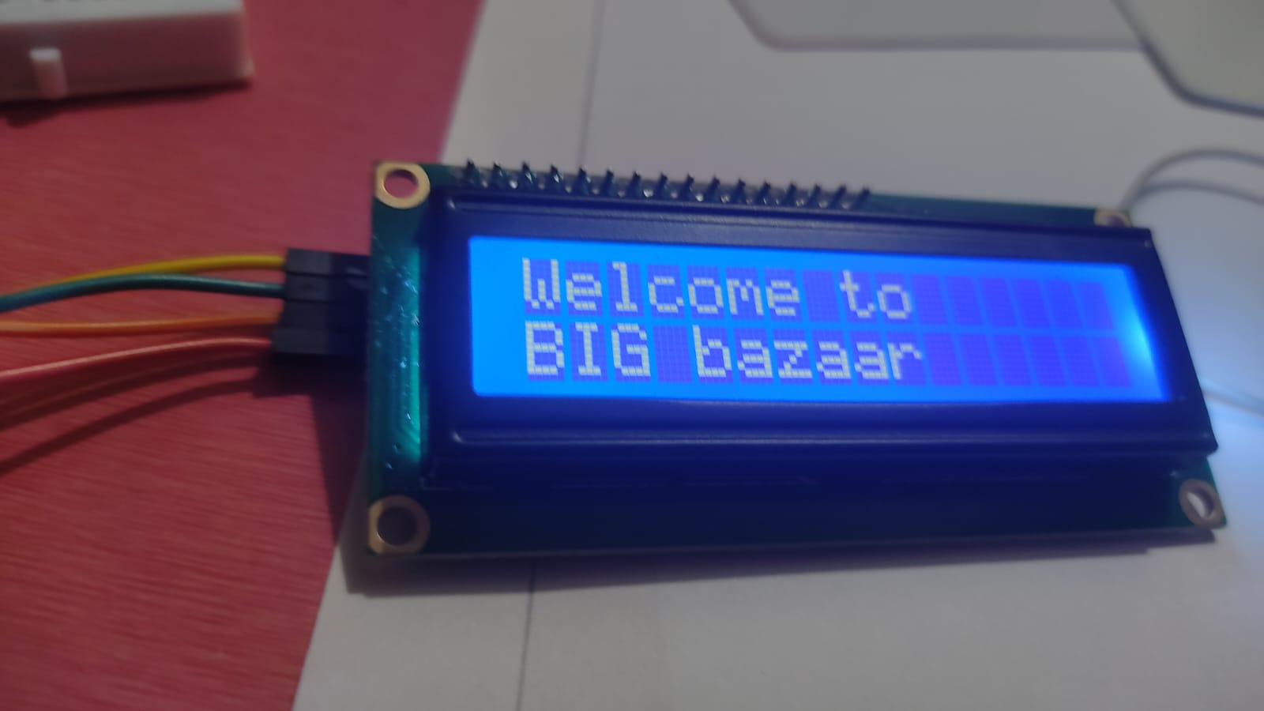

Fig.5. LCD Display

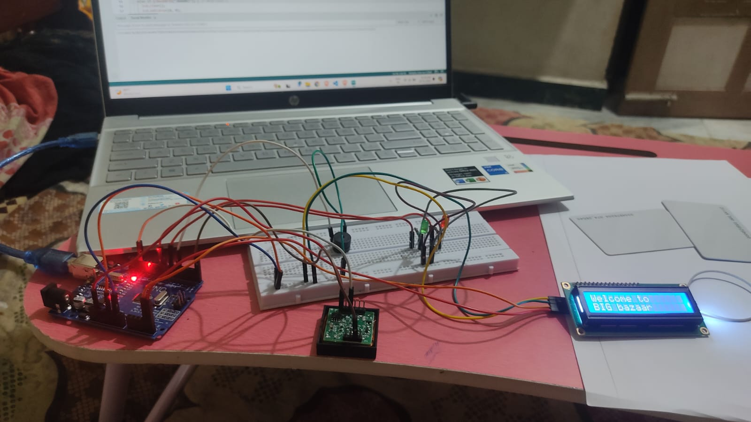

Fig.6. Overview of the product

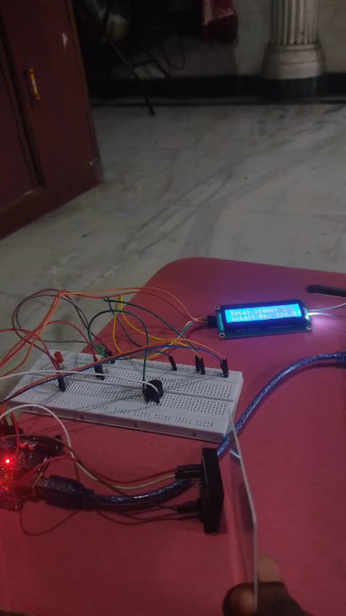

Fig.7. Scanning using RFID card

**VIII. CONCLUSION**

The implementation of an RFID-enabled tracking system represents a significant advancement in retail technology that addresses key issues such as efficiency, effectiveness and customer satisfaction. The system seamlessly integrates RFID technology in a user-friendly manner, enabling real-time scanning, invoice updating and seamless inventory management. The system makes shopping faster and easier for customers, improving the shopping experience by reducing the need for manual checking and reducing human error. Implementation and testing of the system clearly demonstrates its ability to transform traditional sales processes by providing a reliable solution to simplify control processes and improve overall performance.

**IX. FUTURE WORK**

Future development of RFID-enabled tracking systems can focus on several key areas to improve performance and user experience. An improved user experience on LCD displays and mobile applications will increase ease of use and accessibility for all customers. By developing a custom mobile app, users can manage their shopping carts, view real-time updates, and complete transactions right from their phones. Implementing advanced analytics can help retailers improve their performance by providing insights into business behavior, inventory management, and customer preferences. Security improvements will be important to protect customer and company data, ensure privacy, and prevent unauthorized access. Additionally, scaling the system to be able to trade in a wide environment and integrating it with the existing product management system will provide a total solution. Finally, integrating a toll-free payment option can further speed up the payment process and provide additional value to customers. By focusing on these future improvements, RFID-based tracking systems can continue to evolve, providing tremendous benefits to both retailers and customers.

**IX. REFERENCES**

[1] L. B. Ayre, RFID in Libraries: A Step Toward Interoperability. American Library Association, 2012.

[2] P. Reyes, RFID in the Supply Chain. McGraw Hill Professional, 2011.

[3] K. B. Prakash, J. Nayak, B. tp Madhhav, S. Padmanaban, and V. E. Balas, Big Data Analytics and Intelligent Techniques for Smart Cities. CRC Press, 2021.

[4] K. Finkenzeller, RFID Handbook: Fundamentals and Applications in Contactless Smart Cards, Radio Frequency Identification and Near-Field Communication. John Wiley & Sons, 2010.

[5] [V. Mulloni, G. Marchi, A. Gaiardo, M. Valt, M. Donelli, and L. Lorenzelli, “Applications of Chipless RFID Humidity Sensors to Smart Packaging Solutions,” *Sensors* , vol. 24, no. 9, Apr. 2024, doi:](http://paperpile.com/b/3hCTSL/fxD0) [10.3390/s24092879.](http://dx.doi.org/10.3390/s24092879.)

[6] [Y. Bendavid, S. Rostampour, Y. Berrabah, N. Bagheri, and M. Safkhani, “The Rise of Passive RFID RTLS Solutions in Industry 5.0,” *Sensors* , vol. 24, no. 5, Mar. 2024, doi:](http://paperpile.com/b/3hCTSL/ZuCs) [10.3390/s24051711.](http://dx.doi.org/10.3390/s24051711.)